Viscosity and Volumetric studies of some amino acids in  
solutions at different temperatures.

. AH&a Sjlj^ OIajJj AjLaVI ijA JJxi Aa.jjUlj A2lj£ll

Zainab Abbas H.Al-Dulaimy, Asal Ahmed Al- Jawary, Dr.Shatha Fadil Al-saidi .  
Department of Chemistry, College of Education (Ibn-Al-Haitham)

University of Baghdad P.O. Box 4150, Baghdad , Iraq.

Abstract :

Densities p and viscosities n for several concentrations of amino acids (Serine, Cysteine and Threonine) at different temperatures (298.15, 303.15 and 308.15K) have been measured. On the basis of these data, the apparent molal volumes <f>y , partial molal volumes at infinite dilution <f>y,

slope Sv , Gibbs free energy of activation for viscous flow of solution AG1,* and Jones - Dole B- coefficients were calculated the nature of solute-solvent and solute-solute interactions have been discussed in terms of the values of <f>y , <f)y , Sv and B-coefficents.

:

( UjJIzz ^Jl Ail/^ll ol-j^ o^A 'U*

(pv ^jAlill j^jUsh sIa ^/.lAnnl . ( Aaikz 308,15 , 303,15,298,15 ) Sjlj^.

*

(JjJ — AGl 2 ^ Sv , (f}° vw ,

3 SvJ (f)° (j-* t- _ — C_j|jLa £y* ^ ^ dl>aJ 3-

Introduction :

All proteins are polymers consisting of chains of amino acid chemically bound to each other. The amino acid in proteins are called a-amino acid. Each amino acid has a characteristic side chain (R group) that imparts chemical individuality to the molecule. The polarity of the R groups is an important characteristic and is the basis for classifying amino acids into four groups[1]. Amino acids are high water solubilities suggests that they exist in an ionic form (zwitter ion). In physiological media such as blood, membranes, cellular fluids, etc. , where happens to be involved in an important manner, the zwitter ionic (dipolar) character of these compounds has an important bearing on their biological functions[2].

It has been known for sometimes that viscosity measurements can provide direct evidence regarding size and state of solvation of molecules in solution[3]. The variation of relative viscosity with molarity (c) for solutions of dipolar ions or non-electrolytes is normally interpreted in term Jones-Dole equation :-

n ,

nr = I = 1+ Bc + Dc2 (1)

n0

where n and n0 are the viscosities of the solution and the solvent respectively, B and D are empirical coefficients. B is an adjustable parameter which related to the size and shape of the solute molecules and to different solute- solvent interactions. While D coefficient is generally positive. The Dc2 term is usually small for dilute solutions and its significance is not completely understood[4-7]. In recent years interest has been directed to study the behavior of amino acids, peptides and polypeptides in mixed aqueous solvents. Such work is important in understanding the factors that determine the stability of biopolymer[8-11]. From the literature survey it appears that the studies of viscosity and density for a-amino acid solutions are abundant[6-8, 12-14], but on those Serine, cysteine and threonine are few. With this in view, the title study has been undertaken in the light of the following aspects :-

1. Determination of apparent molal volume $v from density data as a function of molal concentration m.
2. Calculate of limiting apparent molal volume <f>y or partial molal volume at infinite dilution.
3. Estimating the Gibbs free energy of activation for viscous flow of solution , AG1,2 from the viscosity and density data.
4. Estimating the Jones-Dole coefficient B(empirical coefficient) from viscosity measurements. These parameters are used to discuss the solute-solvent and solute-solute interactions in the a- amino acids (Serine, Cysteine and Threonine) solutions.

H H OH h

I I II

HO — CH2 — C — COO- HS CH2— C — C°° CH3 — CH — C — COO-

I I I

NH3+ NH3+ nh3+

Serine ( Ser) Cysteine (Cys) Threonine (Thr.)

M=105.1 g mol-1 M=121 g mol-1 M=119 191 g mol-1

All amino acids under study with uncharged polar R group.

Experimental :

Three a-amino acids selected in this work serine, Cysteine and Threonine form Fluka company. They are Analar and used without further treatment. All solutions were prepared with water redistilled (sp.conductivity ~10-6 ohm-1 cm-1). An electrical balance with at least count of 1.0 x 10-4 g was used for measurement of mass.

o

The concentrations of amino acids were in range of 0.1 - 0.35 molar (mol dm- ).

The densitiesp of the solutions were measured at different temperatures 298.15, 303.15 and 308.15K using a vibrating tube digital densimeter ( DMA- 60/602 ; Anton Paar). The operational was described by Shukla et.al.[15].

The viscosity of solutions were measured with an Ostwald suspended level type viscometer as per details described by Findly [16].

Densities and viscosities were measured at 298.15, 303.15 and 308.15K, and carried out in a thermostatted bath, whose temperature was controlled to ± 0.01K for all measurements.

Results and discussion :

The experimental values of densities and absolute viscosities of the Ser, Cys and Thr solutions as a functions of amino acid concentration and temperature are listed in Tables 1,2 and 3 respectively .

|  |  |  |  |  |  |  |
| --- | --- | --- | --- | --- | --- | --- |
| c  mol dm-3 | m  mol kg-1 | P  -3  g cm | n  cP | k  cm3mol-1 | AG1,2  kJ mol-1 | B  dm3mol-1 |
| 298.15K | | | | | | |
| 0.00 | 0.0000 | 0.9907a | 0.890a |  |  |  |
| 0.10 | 0.1009 | 1.0009 | 0.894 | 66.31 | 60.552 | 0.0220 |
| 0.15 | 0.1496 | 1.0030 | 0.901 | 64.68 | 60.577 | 0.0673 |
| 0.20 | 0.2032 | 1.0052 | 0.909 | 64.19 | 60.605 | 0.0953 |
| 0.25 | 0.2548 | 1.0075 | 0.918 | 63.29 | 60.634 | 0.1166 |
| 0.30 | 0.3066 | 1.0100 | 0.925 | 61.95 | 60.658 | 0.1233 |
| 0.35 | 0.3587 | 1.0125 | 0.935 | 60.99 | 60.689 | 0.1377 |
| 303.15K | | | | | | |
| 0.00 | 0.0000 | 0.9956a | 0.798a |  |  |  |
| 0.10 | 0.1011 | 0.9997 | 0.812 | 64.38 | 61.328 | 0.1754 |
| 0.15 | 0.1521 | 1.0019 | 0.821 | 63.37 | 61.361 | 0.1921 |
| 0.20 | 0.2034 | 1.0042 | 0.828 | 62.37 | 61.388 | 0.1880 |
| 0.25 | 0.2550 | 1.0065 | 0.834 | 61.78 | 61.412 | 0.1805 |
| 0.30 | 0.3069 | 1.0090 | 0.841 | 60.69 | 61.438 | 0.1796 |
| 0.35 | 0.3590 | 1.0117 | 0.846 | 59.36 | 61.457 | 0.1719 |
| 308.15K | | | | | | |
| 0.00 | 0.000 | 0.9940a | 0.719a |  |  |  |
| 0.10 | 0.1011 | 0.9992 | 0.733 | 63.40 | 62.079 | 0.1947 |
| 0.15 | 0.1522 | 1.0014 | 0.739 | 62.75 | 62.106 | 0.1852 |
| 0.20 | 0.2035 | 1.0038 | 0.749 | 61.40 | 62.145 | 0.2086 |
| 0.25 | 0.2552 | 1.0062 | 0.758 | 60.59 | 62.180 | 0.2170 |
| 0.30 | 0.3070 | 1.0087 | 0.766 | 59.73 | 62.213 | 0.2179 |
| 0.35 | 0.3592 | 1.0113 | 0.773 | 58.82 | 62.240 | 0.2146 |

Table 1: Densities (p) and viscosities (n) with calculated apparent molal volume (i ) , Gibbs free

* v

energy of activation for viscous flow (AGi,2) and viscosity B-coefficient of Serine in water at different temperatures.

a-ref.(17)

Table 2: Densities (p) and viscosities (n) with calculated apparent molal volume (i ) , Gibbs free energy of

activation for viscous flow (\GL2) and viscosity IB-coefficient of Cysteine in water at different temperatures.

|  |  |  |  |  |  |  |
| --- | --- | --- | --- | --- | --- | --- |
| c  mol dm-3 | m  mol kg-1 | P  -3  g cm | n  cP | i  cm3mol-1 | AG1,2  kJ mol-1 | B  dm3mol-1 |
| 298.15K | | | | | | |
| 0.10 | 0.1011 | 1.0017 | 0.931 | 74.25 | 60.652 | 0.4372 |
| 0.15 | 0.1521 | 1.0042 | 0.939 | 73.21 | 60.683 | 0.3513 |
| 0.20 | 0.2036 | 1.0067 | 0.948 | 72.73 | 60.713 | 0.3139 |
| 0.25 | 0.2553 | 1.0093 | 0.958 | 72.01 | 60.744 | 0.2959 |
| 0.30 | 0.3075 | 1.0119 | 0.969 | 71.56 | 60.780 | 0.2877 |
| 0.35 | 0.3600 | 1.0145 | 0.978 | 71.21 | 60.810 | 0.2755 |
| 303.15K | | | | | | |
| 0.10 | 0.1012 | 1.0004 | 0.825 | 73.33 | 61.370 | 0.3383 |
| 0.15 | 0.1523 | 1.0029 | 0.834 | 72.64 | 61.405 | 0.3008 |
| 0.20 | 0.2038 | 1.0054 | 0.845 | 72.31 | 61.444 | 0.2943 |
| 0.25 | 0.2557 | 1.0080 | 0.854 | 71.71 | 61.478 | 0.2807 |
| 0.30 | 0.3079 | 1.0106 | 0.865 | 71.31 | 61.516 | 0.2799 |
| 0.35 | 0.3605 | 1.0132 | 0.875 | 71.03 | 61.552 | 0.2757 |
| 308.15K | | | | | | |
| 0.10 | 0.1012 | 0.9999 | 0.749 | 72.35 | 62.136 | 0.4173 |
| 0.15 | 0.1524 | 1.0025 | 0.758 | 71.36 | 62.174 | 0.3616 |
| 0.20 | 0.2039 | 1.0051 | 0.765 | 70.86 | 62.204 | 0.3198 |
| 0.25 | 0.2558 | 1.0077 | 0.773 | 70.56 | 62.238 | 0.3004 |
| 0.30 | 0.3080 | 1.0104 | 0.779 | 70.02 | 62.264 | 0.2782 |
| 0.35 | 0.3605 | 1.0131 | 0.788 | 69.63 | 62.300 | 0.2742 |

The densities which were required for determination of the apparent molal volumes & are given by this equation [12].

Table 3: Densities (p) and viscosities (n) with calculated apparent molal volume (& ) , Gibbs free

energy of activation for viscous flow (AGi,2* and viscosity B-coefficient of Threonine in water at different temperatures.

|  |  |  |  |  |  |  |
| --- | --- | --- | --- | --- | --- | --- |
| c  mol dm-3 | m  mol kg-1 | P  g cm-3 | n  cp | &  cm3mol-1 | AG1,2  kJ mol-1 | B  dm3mol-1 |
| 298.15 | XT  IV | | | | | |
| 0.10 | 0.1010 | 1.0016 | 0.919 | 73.20 | 60.622 | 0.3027 |
| 0.15 | 0.1521 | 1.0046 | 0.925 | 72.55 | 60.650 | 0.2466 |
| 0.20 | 0.2035 | 1.0065 | 0.934 | 71.71 | 60.675 | 0.2354 |
| 0.25 | 0.2553 | 1.0090 | 0.940 | 71.21 | 60.698 | 0.2152 |
| 0.30 | 0.3075 | 1.0115 | 0.948 | 70.89 | 60.725 | 0.2093 |
| 0.35 | 0.3599 | 1.0143 | 0.955 | 69.99 | 60.750 | 0.2018 |
| 303.15] | EC | | | | | |
| 0.10 | 0.1012 | 1.0003 | 0.819 | 72.34 | 61.352 | 0.2632 |
| 0.15 | 0.1523 | 1.0027 | 0.828 | 72.00 | 61.386 | 0.2506 |
| 0.20 | 0.2038 | 1.0052 | 0.836 | 71.31 | 61.427 | 0.2381 |
| 0.25 | 0.2556 | 1.0077 | 0.844 | 70.91 | 61.448 | 0.2306 |
| 0.30 | 0.3079 | 1.0102 | 0.854 | 70.65 | 61.484 | 0.2339 |
| 0.35 | 0.3604 | 1.0129 | 0.862 | 69.88 | 61.513 | 0.2291 |
| 308.15] | EC | | | | | |
| 0.10 | 0.1014 | 0.9998 | 0.742 | 71.46 | 62.112 | 0.3198 |
| 0.15 | 0.1524 | 1.0023 | 0.749 | 70.70 | 62.143 | 0.2782 |
| 0.20 | 0.2039 | 1.0048 | 0.755 | 70.36 | 62.170 | 0.2503 |
| 0.25 | 0.2557 | 1.0074 | 0.762 | 69.75 | 62.200 | 0.2392 |
| 0.30 | 0.3079 | 1.0101 | 0.769 | 69.01 | 62.229 | 0.2318 |
| 0.35 | 0.3604 | 1.0127 | 0.774 | 68.77 | 62.252 | 0.2186 |

Po

(2)

solution respectively. M is the molecular

Where p0 and p are the densities of solvent and weight of solute and m is the molality

[ m=1/(

p _M_ c -1000

)]

. The calculated values of the

for three amino

acids with different temperatures are also reported in Tables 1,2 and 3.

In general, & values decrease with increase temperature and concentration for all amino acids under study with the sequence of & values : Cys > Thr > Ser . It indicates that the solute-solvent interactions decrease with increasing concentration [18].

The variation of the apparent molal volumes & wih molal concentration m can be adequately represented by the relation:

<f>v = <f>; + Sv m

(3)

where <f>° is the limiting value of the apparent molal volume ( equal to partial molal volume at infinite dilution ) and Sv is experimental slope ( empirical constant) [8,12,13]. The values of h vs. m are plotted for Ser,Cys and Thr at different temperatures shown in Figure 1. The plot of h against m should be linear with a slope Sv and an intercept of (p° when m—>o.

The values of (p° and Sv are listed in Table 4 .

Series 1 Series2 Series3



298.15K — 303.15K —

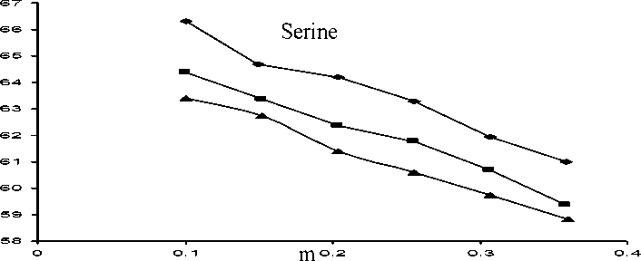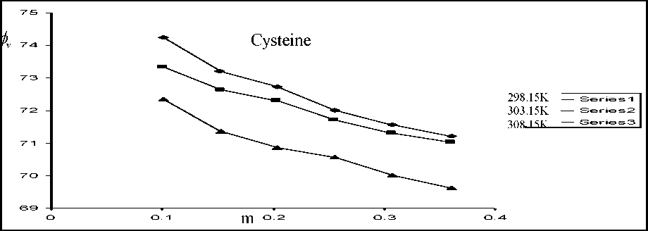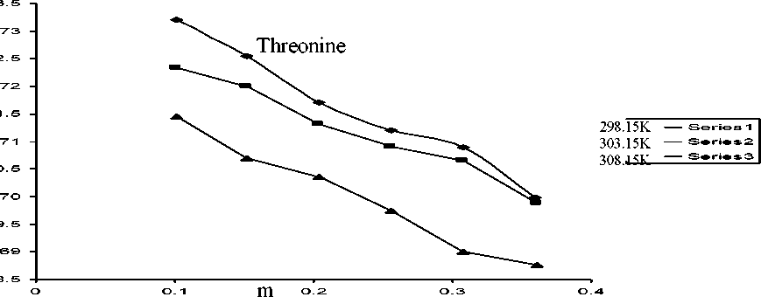

Figure 1 : Plot of

vs. m for amino acids at different temperatures

Table 4 : Values of apparent molal volume at infinite dilution <f>° and experimental slope Sv of Ser, Cys and Thr at 298.15, 308.15 and 308.15K.

|  |  |  |  |  |  |  |  |
| --- | --- | --- | --- | --- | --- | --- | --- |
| Solute | 298.15K | | 303.15K | |  | 308.15K | |
| €  cm3mol-1 | Sv  3 2  cm mol- kg | €  cm3mol-1 | Sv  3 2  cm mol- kg |  | €  cm3mol-1 | Sv  3 2  cm mol- kg |
| Serine | 68.07 | -19.678 | 66.28 | -18.685 | | 65.28 | -18.137 |
| Cystein | 75.14 | -11.508 | 74.09 | -8.859 | | 73.07 | -9.865 |
| Threonine | 74.32 | -11.876 | 73.31 | -9.237 | | 72.44 | -10.547 |

Table 4 shows that all the values of Sv are negative, indicating the presence of weak solute- solute interactions in solution[19-21]. Moreover, the values of Sv become less negative with increase temperature for the three amino acids, suggesting increased solute-solute interaction with increase temperature. In fact negative Sv values are often obtained in solvents of high dielectric constant [19], A perusal of Table 4 reveals that the values of $ are positive for all the three amino-acid solutions, suggesting strong solute-solvent interactions[20,21]. For Cysteine the value obtained for (f>° at 298.15K (75.14 cm mol' ) is in reasonable agreement with the (73.44 cm mol' ) obtained by

Millero et.al.[22].In general, </)° values are in the sequence : Cys > Thr > Ser. The </)° values decrease with increase in temperature for all amino acids under study (Table 4), indicating that the solute-solvent interaction decreases with increase in temperature[18-21].

From transition state theory the Gibbs free energy of activation for viscous flow of solution, AG*2 (J mol-1) at a given temperature and composition is given by [23,24]

AG^ = RT Ln ( ———2 ( 4)

, hN

Where R is the gas constant, T is the absolute temperature, h is plank s constant, N is Avogadro s constant and the volume of mole of solution is V1,2 obtained from the relation V1,2 = (103 + mM2 ) /p (-——+ m) .Where M1 and M2 are molecular weight for solvent and solute respectively. The values for ^ calculated via the equation (4) for Ser, Cys and Thr are given in Table 1,2 and 3 respectively. Tables 1,2 and 3 shows that the values of AG 1,2 increase with increase of concentrations and temperature for Ser, Cys and Thr.

Jones-Dole coefficient B is a measure of structural modification induced by solute- solvent interactions [25,26].

The values of B coefficient have been obtained by using the following equation . nr = 1+ Bc (5)

The values of B are included in Tables 1,2 and 3 . These Tables indicate that the values of B- coefficients are positive, for all amino acids studied and follow the order BCys > BThr > BSer suggesting solute- solvent interactions.

Thus the values of coefficient B support the behaviours of <f>° and Sv. which all suggest

solute- solvent interactions compared to solute-solute interactions in these amino acid systems. Also, the increasing value of B-coefficients with the rise in temperature further support our earlier conclusion ( drawn from the variation of and Sv with temperature) that solute- solvent interactions decrease while solute-solute interactions increase with a rise temperature.

References :

1. Seager S.L.and Slabaugh M.R., " Organic and Biochemistry for Today ", 3 ed , Brooks cole Puplshing company, 1997.

2.Zubay G.L., Parson W.W and Vance D.E., "Principle of Biochemistry Energy, Proteins and Catalysis ",2nd ed., vol 1,WCP Wm.C.Brown publishers, 1995.

3.Stokes R.H. and Mills R., "Viscosity of electrolytes and related properties", Pergamon London, 1965.

1. Desnoyers J.E. and Perron G., J. Solution Chem., 3 (1),199, 1972.
2. Tyrrell H.J.V. and Kennerley M., J. Chem. Soc.A, 90, 2724, 1968.
3. Tsangaris M. and Martin R.B., Arch. Biochem. Biophys., 112, 267, 1965.
4. Manson L.S., Kapmeyer P.M. and Robinson A.L., J. Amer Chem. Soc., 74, 1287, 1952.
5. Mishra A.K. and Ahluwalia J.C., J. Chem. Soc., Faraday Trans. I, 77, 1469, 1981.
6. Phang S., Aust. J. Chem., 30, 1605, 1977.
7. Dey N.C., Saikia B.K. and Hague, I. Can J. Chem., 58, 1512, 1980.
8. Noudeh G.D., Taulier N. and Chalikian T.V., Biopolymers, 70, 563, 2003.
9. Devine W. and lowe B.M., J. Chem. Soc. A, 2113, 1971.
10. Pal A. and Kumar S., J. Chem. Soc., 117 (3), 267, 2005.
11. Ogawa T., Mizutani K. and Yasuda M., Bull. Chem. Soc. Jpn., 57(8), 2064, 1984.
12. Shukla R.S., Shukla A.K., Raid R.D. and Pandey J.D., J. Phys. Chem., 93, 4627, 1989.
13. Findlay A., "Practical physical chemistry ", 8th ed., J.A. Kitchner (London : Longman) , 1954.
14. "Handbook of Chemistry and Physics", 68 ed., CRC Press, 1981-1988.
15. Ali A. and Shohjahan, Z.Phys.Chem.,222,2008.
16. Ali A., Nain A.K., Kumar N. and Ibrahim M., Proc. Indian Acad. Sci. (Chem. Sci.), 114(5), 495, 2002.
17. Gupta R. and Singh M.,J. Chem. Sci, 117(3),275,2005.
18. Ali A., Sabir S., Nain A.K., Hyder S., Ahmad S., Tariq M. and Patel R., J.Chin. Chem. Soc.,54,659,2007.
19. Millero F.J., Surdo A.Lo and Shin C., J. Phys. Chem.,82(7), 784, 1978.
20. Glasstone S., Laidler K.J. and Eyring H., "The Theory of Rate Processes ", 1st ed., Mc Graw- Hill, New York, 1941.
21. Klofutar C., Palyk S. and Kac M., Thermochimica Acta, 153, 297, 1989.
22. Feakins D., Freemantle D.J. and Lawrence K.G., J. Chem. Soc., Faraday Trans. I, 70, 795, 1974.
23. Bai T.C. and Yan G.B., Carbohydr. Res., 338, 2921, 1999.